The ZEP permits
By Oswald Kucherera

Yesterday,
I was overwhelmed with great joy,
beaming with an innocent smile,
when the ZEP permits were issued.
I felt like screaming on top of my lungs like a child,
carefree,
filled with unbridled happiness.
A giant step towards freedom and unity,
the common ground of the founding fathers and mothers of African independence.
My spirit had finally found peace,
And I could walk tall brimming with self-confidence.
No longer at tenterhooks with the authorities,
my heart throbbing at the speed of the sound of sirens,
on the sight of police officers
Or the Home Affairs officials.
I remain an outsider,
It doesn't count,
I learnt to speak the language.
I carry with me my blackness
everywhere I go,
but it's not enough passport,
in the eyes of the authorities.
I had regained my dignity,
lost when I crossed the borders
And rendered illegal immigrant
on the African soil
the home of Ubuntu.
It was all a sweet escape from crass tyranny
And abject poverty
trying to stay alive,
And keep the home fires burning,
chasing away the cat from the fireplace.
The fascist regime back home,
plunged the promising country into a basket case,
And failed to find the panacea to the hemorrhaging economy
And the citizens are scattered in forlorn exile.
Descending voices,
are callously thrown behind bars,
Or disappear without trace.
August, the beginning of spring, never forgot
6 unarmed protesters gunned down on streets of Harare,
suffered a brutal death at the hands of the soldiers,
despots clinging on to power; at all cost.
When the ZEP permits were issued,
The African gods had answered my prayers
I could finally walk freely on the streets,
apply for a decent job,
earn a decent income,
And afford to send remittances back home.
I was determined to employ my knowledge and skills,
And put them to optimum use,
in the development
and betterment of humankind.
I remember the humiliation I was subjected to roaming the streets undocumented,
the exploitation,
the desperation,
the perpetual fear of deportation,
the constant rage,
the miserable wage,
in the belly of the beasts,
sucking my blood dry,
seeking to reap of large profits.
When I finally got the ZEP permit,
I was ravished this was all in the past,
the end of the trials and tribulations,
the beginning of the new.
I perceived it will be different
and the agony will be gone.
I never asked much
I only needed a little to feed and clothe my family
and sustain education for my offspring,
looking after the old and ailing back home.

Today,
I feel like I am at a brink
descending back to the squalor.
Every day I drink,
copious amounts of liquor.
I have very little time to clearly think,
Drinking has become my refuge,
my coping mechanism
Or escapism.
The growing uncertainty,
friendships,
relationships,
the small life I had built here
in my second home.
the uncertainty eats deep in my system like a disease
the dashing hopes and dreams
the future
the unpredictable future and its features.
the unseen obstacle threatens to crumble down
The self-esteem and self-confidence
slowly dimming.
The ZEP permit breathed life in me
and gave me the power of free will
And like an eagle
I could soar to depth heights
high up in the sky.

Tomorrow,
looks promising.
Winter is slowly coming to an end,
marking the birth of new season,
ushering in a splendid summer.
Reason will finally prevail
And the ZEP permits will be renewed.

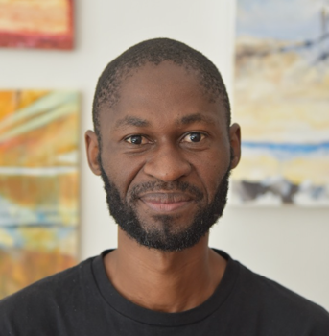
Oswald Kucherera is an avid reader, short story writer, poet, novelist and pan-Africanist activist currently residing in Cape Town. He is an author of the best-selling self-published novella, The Exodus Down South (2016) and Washing Dishes and Other Stories (2018). His work is published in various publications including Sleeping Giants Awakes (2018) and Migrants, Thinkers, Storytellers (2021). He is a contributing writer for FUNDZA, an online publication. In 2017 and 2018 he participated as a panelist in the prestigious Open Book Festival. In 2022 he participated as a panelist in Blown Away By Books Festival at Fish Hoek Library. He has a passion for photography and travelling.

